# Line, Line Segment and Rays

**Line:** Lines have no endpoint and continues forever in both directions.

**Line Segment:** Line segment has two endpoints, and it is finite in both directions.

**Ray:** Ray has a starting point, but it keeps on going forever on the other direction.

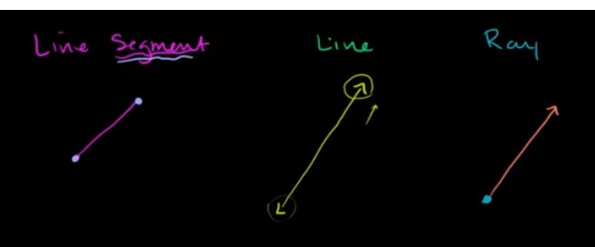

**Planes:** 2 points isn’t sufficient to define a plane, cause infinite number of planes can go through them. A plane is defined by 3 non-co-linear points(they don’t lie in same line).

# Triangle

**Triangle inequality rule:** Length of any side of the triangle has to be less than the sum of the length of other two side.